Name ________________________________________________ Date ________________

Leonardo da Vinci Inventions
http://www.geniusstuff.com/blog/list/10-leonardo-da-vinci-inventions/

Leonardo da Vinci may well have been the greatest inventor in history, yet he had very little effect on the technology of his time. Da Vinci drew sketches and diagrams of his inventions, which he preserved in his notebooks, but either he lost interest in building them or was never able to convince one of his wealthy patrons to finance construction of his designs. As a result, almost none of da Vinci's inventions were built during his lifetime. And, because he never published his diagrams, nobody else knew about them until his notebooks were discovered long after his death.
That's a pity, because da Vinci's designs were spectacularly ahead of his time. If they had been built, they might have revolutionized the history of technology, though many of them may have been impossible to build with the tools available in the 15th and 16th centuries. In recent years, however, engineers have begun to construct models of da Vinci's amazing machines and most of them actually work. In the following pages we'll look at some of the most imaginative -- and coolest -- of the designs that da Vinci sketched out in his notebooks.

Directions: Choose 3 inventions created by Leonardo da Vinci. Describe 2 details about each one.

Invention #1:
Name of Invention:
Invention #2:
Name of Invention:

Invention #3:
Name of Invention:
Which invention do you think has been most beneficial to modern the world? Explain why.

__________________________________________________________________________________________________________________________________________________________________________________________________________________________________________________________________________________________________________________________________________________________________________________________________________________________________________________________________

If you could meet Leonardo da Vinci, what 3 questions you would ask him about his inventions?

Question #1:
____________________________________________________________________________________________________________________________________________________________________________________

Question #2:
____________________________________________________________________________________________________________________________________________________________________________________

Question #3:
____________________________________________________________________________________________________________________________________________________________________________________

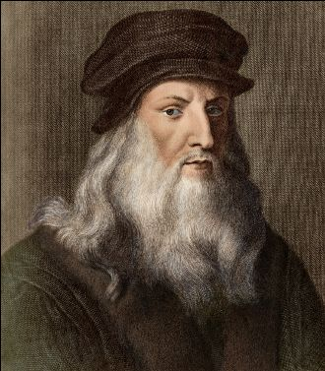
Leonardo da Vinci inventions: https://www.youtube.com/watch?v=PwOlIGGDVjE

